[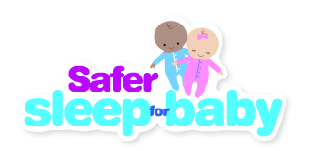](https://www.google.com/url?sa=i&url=https://en.wikipedia.org/wiki/Sudden_infant_death_syndrome&psig=AOvVaw3qgb3-doClZ8NlhWMraRls&ust=1581783360565000&source=images&cd=vfe&ved=0CAIQjRxqFwoTCNjUzLC40ecCFQAAAAAdAAAAABAD)**Follow Our Six Steps to Safer Sleep for Baby**

|  |  |
| --- | --- |
|  | 1. Keep baby away from smoke before and after birth |
|  | 2.Put baby in a cot, crib or moses basket to sleep  Never fall asleep with baby on a sofa or chair |
|  | 3.Never fall asleep with baby after drinking or  taking drugs or medication |
|  | 4.Put your baby to sleep on their back with their feet to the foot of the cot |
|  | 5.Keep baby's head and face uncovered and make sure they don’t get too hot |
|  | 6.Breastfeed your baby – support is available if you need it |

Babies should sleep in the same room as the adult who is caring for them, for every sleep, for at least the first 6 months of life. In their own cot, crib or Moses basket.

**Together we can reduce the number of babies dying unexpectedly each year**