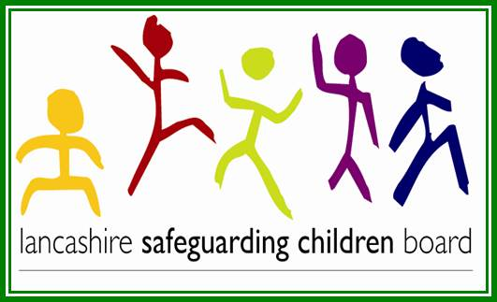

Ofsted is today publishing both the report of the Inspection of services for children in Lancashire and a Review of the effectiveness of the Lancashire Safeguarding Children Board (LSCB).  A copy of the report can be found on our web-site. Out of a range of four possible grades (inadequate, requires improvement, good and outstanding) the judgement in respect of the LSCB is that it is "good".  This reflects the commitment of all agencies in working together to safeguarding children and establishing strong partnership arrangements.

As Chair of the Safeguarding Children Board I welcome the report of the LSCB review and its finding of "good".  However the report of the inspection of services for children found them to be "inadequate" and this is a cause for serious concern.  Although Ofsted considered the LSCB activity to quality assure services to be good I am planning to review this to ensure that the Board's role in challenging agencies' about their performance is strengthened.

The Review of the LSCB has made four recommendations as follows:

1. The LSCB should analyse and report on the prevalence of female genital mutilation to hold agencies to account for their practice in protecting girls at risk or in need of services;
2. Ensure the LSCB annual report fully reflects the analysis and conclusions the Board has reached, particularly any changing trends and categories of child protection plans, and what this means for understanding the effectiveness of performance and the quality of frontline practice;
3. The LSCB should further support and challenge the local authority in making the necessary improvement to its help and protection provision and its services to care leavers; and
4. The LSCB should take action to extend its understanding of the application of thresholds beyond early help to every stage of the child's journey.

Action has already been taken to complete the first two recommendations.  The LSCB will be play a full and active role in the improvement in services for children. It will increase its effectiveness and capacity to support and challenge the local authority.  The review of the LSCBs quality assurance work will ensure the fourth recommendation is fully addressed.

Jane Booth

Independent Chair

Lancashire Safeguarding Children Board

Tel: 07795061538